Design a webpage (Responsive)!

Index.html

<!DOCTYPE html>

<html>

<head>

<title> Freeeze </title>

<meta name="viewport" content="width=device-width, initial-scale=1.0">

<link rel="stylesheet" type="text/css" href="style.css">

</head>

<body>

<header id="header">

<img src="images/logo.png">

<a href="#" class="hide-desktop">

<img src="images/ham.svg" alt="toggle menu" class="menu" id="menu">

</a>

<nav>

<ul class="show-desktop hide-mobile" id="nav">

<li id="exit" class="exit-btn hide-desktop">

<img src="images/exit.svg" alt="exit menu">

</li>

<li><a href="#" id="active">HOME</a></li>

<li><a href="#">ABOUT</a></li>

<li><a href="#">BLOG</a></li>

<li><a href="#">CONTACT</a></li>

</ul>

</nav>

</header>

<section id="section">

<div id="bg-image">

<img src="images/bg-home.jpg">

<a href="#"><div id="circle">

<img src="images/circle.png">

<p>FREEZE <br> DELIGHT</p>

</div></a>

</div>

<div id="main-section">

<div id="main-content">

<h3>NEW PRODUCT</h3>

<h1>The Twist of Healthy Yogurt</h1>

<p>This website template has been designed by <br>

<a href="#">kamal pandey</a><br>

for you,for free. you can replace all this text with your own text.

</p>

</div>

<div id="content-img">

<img src="images/yogurt.jpg">

</div>

</div>

<div id="categories">

<div class="categories-items">

<a href="#"><img src="images/products.png"></a>

<p>PRODUCTS</p>

</div>

<div class="categories-items">

<a href="#"><img src="images/ourstory.png"></a>

<p>OUR STORY</p>

</div>

<div class="categories-items">

<a href="#"><img src="images/flavours.png"></a>

<p>FLAVOURS</p>

</div>

<div class="categories-items">

<a href="#"><img src="images/location.png"></a>

<p>OUR LOCATION</p>

</div>

</div>

</section>

<footer id="footer">

<div id="footer-icons">

<div class="social-media-icons">

<a href="#"><img src="images/facebook.png"></a>

</div>

<div class="social-media-icons">

<a href="#"><img src="images/twitter.png"></a>

</div>

<div class="social-media-icons">

<a href="#"><img src="images/googleplus.png"></a>

</div>

<div class="social-media-icons">

<a href="#"><img src="images/pinterest.png"></a>

</div>

</div>

<div id="copyright">

<p>&copy; 2023 Freeeze. All Rights Reserved.</p>

</div>

</footer>

<script>

var menu = document.getElementById('menu');

var nav = document.getElementById('nav');

var exit = document.getElementById('exit');

menu.addEventListener('click', function(e) {

nav.classList.toggle('hide-mobile');

e.preventDefault();

});

exit.addEventListener('click', function(e) {

nav.classList.add('hide-mobile');

e.preventDefault();

});

</script>

</body>

</html>

**style.css**

body{

height: 100%;

width: 100%;

margin: 0px;

padding: 0px;

}

nav{

float: right;

display: flex;

}

#header{

background-color: #eee9ea;

padding: 35px 200px;

}

#header ul{

list-style-type: none;

}

#header ul li{

padding-right: 60px ;

display: inline;

}

#header ul li a{

text-decoration: none;

color: #996372;

}

#header ul li a:hover{

color: #ec82b5;

}

a#active:link, a#active:visited{

color:#ec82b5;

}

#bg-image img{

width: 100%;

margin-bottom: 0;

}

#bg-image{

position:relative;

}

#circle{

height: 150px;

width: 150px;

position: absolute;

bottom: 100px;

right: 300px;

}

#circle p{

position: absolute;

color: white;

bottom: 25px;

right: 15px;

font-size: 25px;

}

#main-section{

background-color: #eae4e6;

display: flex;

}

#main-content{

padding: 40px 200px 0px 200px;

}

#main-content h3{

font-weight: lighter;

color:#996372;

}

#main-content h1{

font-weight: lighter;

color:#fb21ad;

font-size: 30px;

}

#main-content p{

color: #996372;

line-height: 25px;

}

#main-content a{

color: #996372;

}

#content-img{

margin-bottom: -5px;

}

#categories{

background-color: #a4eb00;

display: flex;

width: 100%;

padding: 0px 220px;

box-sizing: border-box;

justify-content: center;

text-align: center;

}

.categories-items{

margin: 20px 50px;

color: white;

font-weight: bold;

}

.categories-items img{

width: 100px;

height: 60px;

}

footer{

width:100%;

background-color: #fb21ad;

color: #ffffff;

text-align: center;

padding: 50px 0px;

}

#footer-icons{

display: flex;

justify-content: center;

}

#footer-icons img{

padding: 15px;

}

#footer p{

font-size: 15px;

}

.hide-desktop {

display: none;

}

{

display: none;

}

@media only screen and (max-width: 850px) {

body {

width: 100%;

}

.menu {

width: 25px;

margin-top: 45%;

}

#header{

background-color: #eee9ea;

padding: 10px;

}

.hide-desktop {

display: inline-flex;

margin-left: 120px;

padding-bottom: 0;

}

nav ul {

position: fixed;

width: 60%;

top: 0;

right: 0;

text-align: left;

background: rgb(36,41,44);

height: 100%;

z-index: 7;

padding-top: 3em;

}

nav ul li a {

color: white;

text-decoration: none;

display: block;

width: 100%;

padding: 1em 2em;

background-color: rgb(49, 55, 59);

}

#header ul li{

padding: 10px;

}

#header ul{

padding : 0;

}

.hide-mobile {

display: none;

}

#bg-image{

width: 100%;

padding: 0;

margin: 0;

box-sizing: border-box;

}

#circle{

height: 90px;

width: 90px;

position: absolute;

bottom: 5px;

right: 120px;

}

#circle p{

position: absolute;

color: white;

bottom: 15px;

right: 10px;

font-size: 15px;

}

#main-section {

background-color: #eae4e6;

display: block;

padding: 30px 0 0px 0;

text-align: center;

}

#categories{

display: block;

padding: 20px 0;

}

#main-content{

padding: 20px;

text-align: justify;

}

#content-img img{

width: 250px;

height: 250px;

}

}

**Output:**

**For Web**

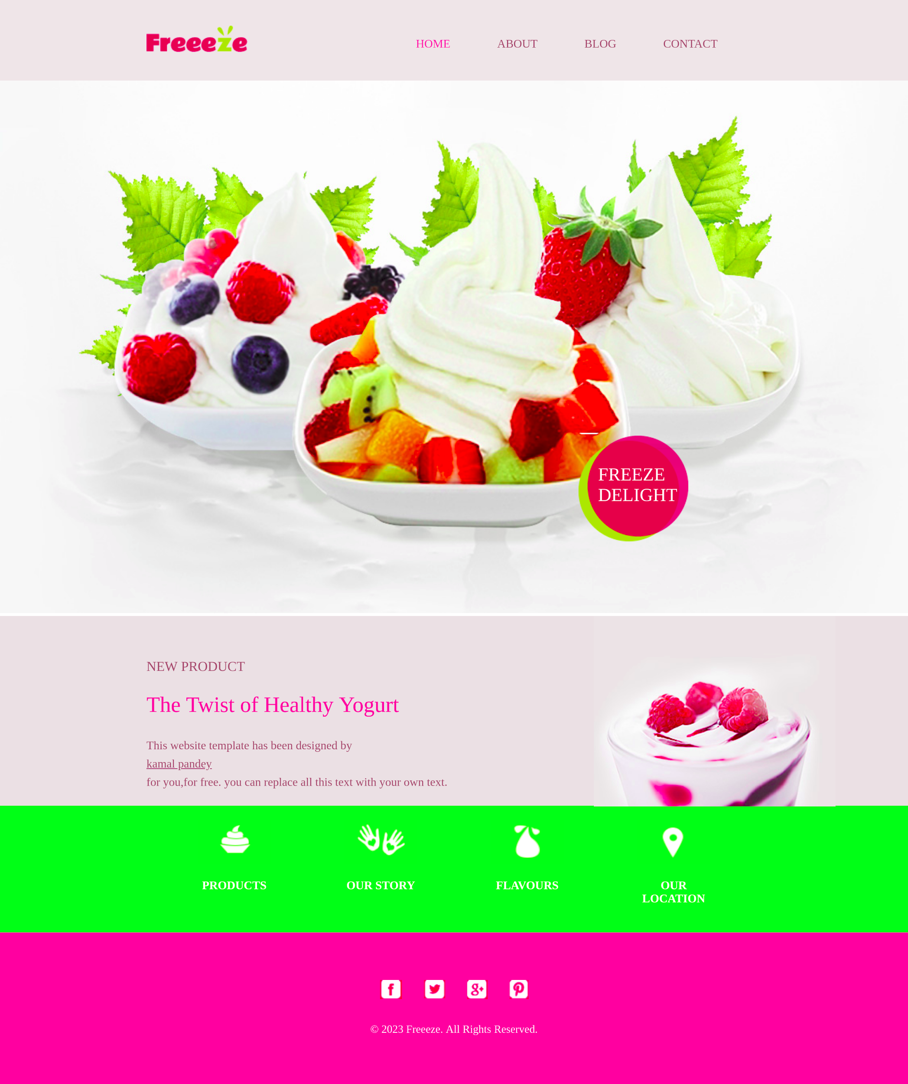

**For Mobile:**

